|  |  |  |  |  |  |  |  |  |  |
| --- | --- | --- | --- | --- | --- | --- | --- | --- | --- |
| **PaNOSC** | **DELIVERABLES** | | M | **MILESTONES** | | M | INTERNAL MILESTONES | | M |
| WP1 Management | D1.1 | Project initiation Documentation | 2 | MS1.1 | Project Initiation Stage completed | 2 | IMS2.1a | Draft of new data policy framework | 12 |
| D1.2 | Mid-Year summary | 6x | MS1.2 | First Annual report | 12 | IMS2.2a | Plan of how the DP will be adopted… | 18 |
| D1.3 | Annual workshop report | 12x | MS1.3 | Second Annual report | 24 | IMS2.4a | Draft guidelines for DP best practices | 12 |
| D1.4 | Data management plan | 6 | MS1.4 | Third Annual report | 26 | IMS2.5a | DMP design | 24 |
| WP2 Data Policy and Stewardship | D2.1 | PaNOSC data policy framework… | 18 | MS1.5 | Final Annual report | 48 | IMS2.6a | DP adoption status report | 24 |
| D2.2 | TMP Template published | 36 | MS2.1 | First version of PaNOSC DP… | 12 | IMS2.7a | DMP online | 36 |
| D2.3 | Guidelines published | 24 | MS2.2 | Adoption of PaNOSC DP framework | 24 | IM3.1 | WP3 Meeting at GA | 12 |
| D2.4 | Integration of the policy… | 36 | MS2.3 | Implementation of PaNOSC DP… | 36 | IM3.2 | API Feedback from ExPaNDS | 16 |
| WP3 Data Catalog Services | D3.1 | API Definition | 18 | MS3.1 | Survey of Catalogue APIS and… | 12 | IM3.3 | Community Meeting on NeXus… | 16 |
| D3.2 | Demonstrator implementation | 28 | MS3.2 | Anthology Feedback to API Tasks | 12 | IM3.4 | WP3 Meeting at GA | 24 |
| D3.3 | Catalog service | 40 | MS3.3 | Catalogue Integration Best … | 30 | IM3.5 | Draft Proposed Metadata Schema... | 24 |
| D3.4 | Implementation report from facilities | 44 |  |  |  | IM3.6 | ExPaNDS Catalogue Release | 33 |
| D3.5 | NeXus Metadata Mapping Schema… | 42 |  |  |  | IM3.7 | WP3 Meeting at GA | 36 |
| WP4 Data Analysis Services | D4.1 | Report data analysis capture | 12 | MS4.1 | Prototype data analysis services… | 18 | IMS4.1a | architecture and design of DAAS | 12 |
| D4.2 | Prototype remote desktop and … | 18 | MS4.2 | Data analysis services accessible… | 42 | IMS4.2a | web visualisation demonstrator | 30 |
| D4.3 | Remote desktop and Jupyter … | 42 | MS5.1 | Simulation codes in PaNData… | 6 | IMS5.1a | containers for simulation services | 12 |
| D4.4 | Jupyter based analysis services | 48 | MS5.2 | Demonstration of simulation… | 24 | IMS5.2a | infrastructure for simulation services | 24 |
| WP5 Virtual Neutron and X-ray Laboratory | D5.1 | Prototype simulation data formats | 12 | MS5.3 | VINYL software release | 42 | IMS5.2b | Report on user feedback… | 36 |
| D5.2 | Documented simulation APIs | 24 | MS5.4 | Validation of simulation services | 48 | IMS6.1a | AAI prototype | 12 |
| D5.3 | Documented simulation tasks… | 42 |  |  |  | IMS6.2a | data transfer demonstrator | 12 |
| T5.4 | Software tested & released… | 48 |  |  |  | IMS7 |  |  |
| WP6 EOSC Integration | D6.1 | DataHub: EGI DataHub integration… | 18 | MS6.1 | Implementation of AAI integration… | 36 | IMS8.1 | VC preparation for annual meeting… | 10 |
| D6.2 | Compute cloud: integration… | 12 | MS6.2 | First release of PaNOSC services | 18 | IMS8.2 | Solution for Jupyter integration… | 13 |
| D6.3 | AAI: Integration of the PaN AAI… | 36 | MS6.3 | Second release of PaNOSC services… | 36 | IMS8.3 | Budget clarification for hardware… | 14 |
| D6.4 | Software catalogue: Demonstration… | 24 |  |  |  | IMS8.4 | Mid-year VC completed | 18 |
| D6.5 | Report on EOSC integration | 48 |  |  |  | IMS8.5 | MS8.4 moved forward… | 25 |
| WP7 Sustainability | D7.1 | Photon and Neutron EOSC… | 18 | MS7.1 | Stakeholder database ready | 6 | IMS8.6 | Wish-list from partners defined… | 13 |
| D7.2 | Photon and Neutron EOSC metrics… | 36 | MS7.2 | Final Sustainability Plan | 48 | IMS8.7 | Workshop scheduled [T8.3] | 15 |
| D7.3 | Photon and Neutron EOSC Business… | 42 |  |  |  | IMS8.8 | First facility specific course… | 18 |
| D7.4 | Photon and Neutron EOSC Sustain… | 48 | MS8.1 | Joint WP4 & 8 plan | 6 | IMS8.9 | Course / tutorial using Jupyter… | 25 |
| WP8 Staff training in data stewardship | D8.1 | Report on lessons learned and… | 32 | MS8.2 | Joint WP5 & 8 plan | 6 | IMS8.10 | Mid-year VC completed | 30 |
| D8.2 | Report on lessons learned for… | 42 | MS8.3 | pan-learning.org up running | 15 | IMS8.11 | 2nd facility specific course… | 31 |
| D8.3 | Teaching material accessible… | 42 | MS8.4 | Jupyter integrated with e-learning… | 30 | IMS8.12 | Mid-year VC completed | 42 |
| D8.4 | Closing report … | 48 | MS8.5 | e-learning virtual facilities | 36 | IMS9.1 | Report on Y1 outreach activities… | 13 |
| WP9 Outreach &Communication | D9.1 | PaNOSC’s Communication and … | 7 | MS9.1 | PaNOSC’s Website Ready | 6 | IMS9.2 | All website sections completed | 12 |
| D9.2 | PaNOSC’s Website | 6 |  |  |  | IMS9.3 | First use cases (2-3) published… | 12 |
| D9.3 | PaNOSC’s repository for internal … | 3 |  |  |  | IMS9.4 | List of user meetings defined… | 12 |
| D9.3 | Dissemination and Outreach act… | 48 |  |  |  |  |  |  |
| D9.4 | Project initiation Documentation | 48 |  |  |  |  |  |  |

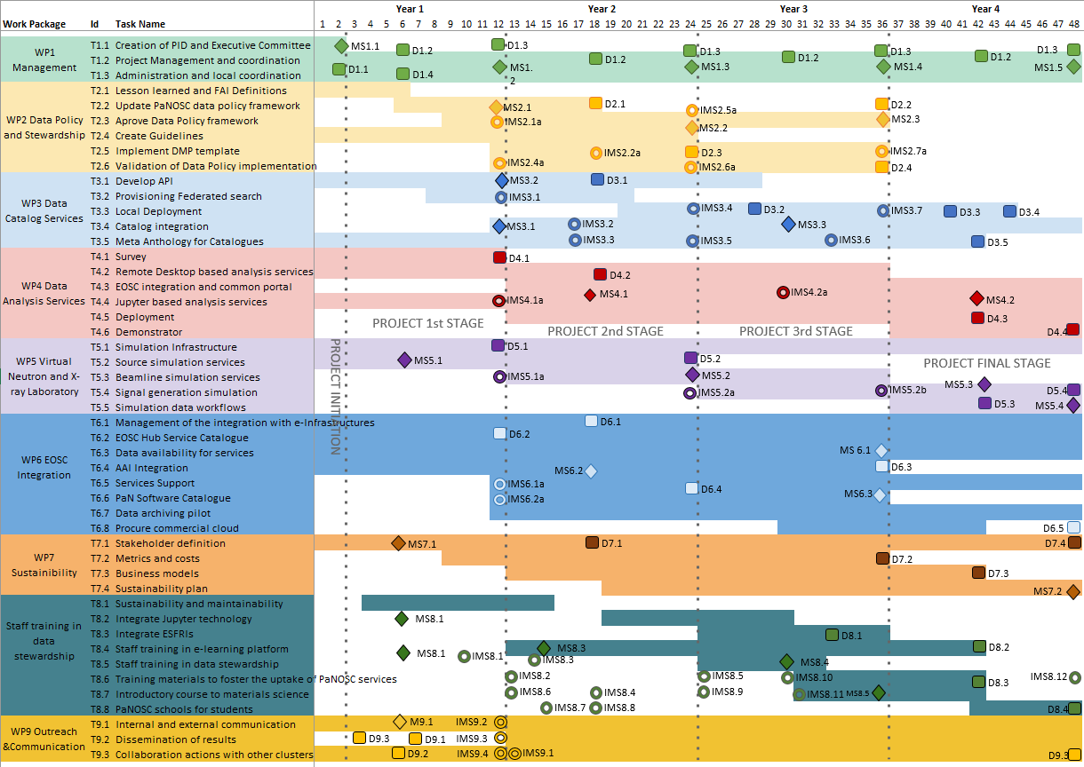  


**PaNOSC** timeline